Figure 2

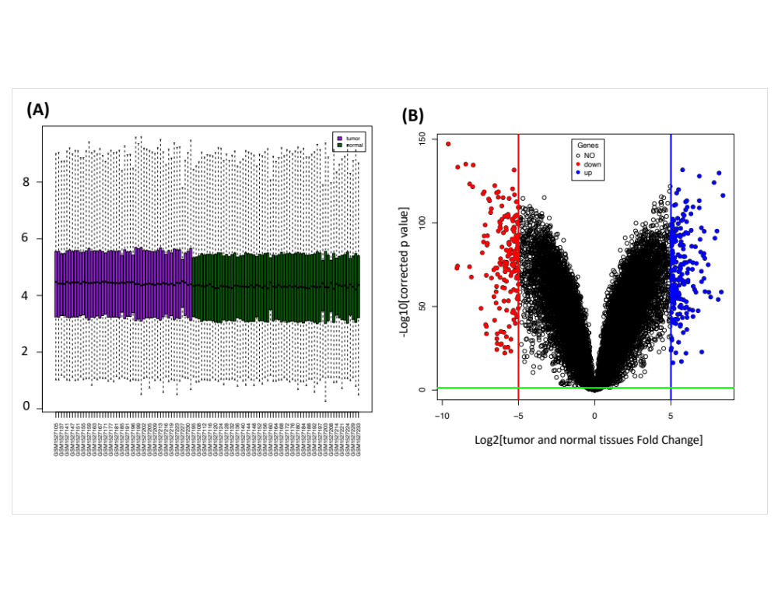

Figure 2. (A) The boxplot shows gene expression values of each patient of the raw data without normalization. (B) Plots displaying the expression discrepancy in PDAC tumor and normal tissues comparison. Black illustrates no change (NO), red illustrates down-regulated (Down), and blue illustrates up-regulated (Up) DEGs, FC, fold change.

